Instructions for the Signalbox Simulator
Controller is powered from the blockshelf 12V dc supply so it should come on when the blockshelf is switched on downstairs. There is an on/off switch on the main box which is situated behind the track diagram panel. If the LED isn’t on, check the supply or the fuse.
There is a small control box on the right-hand end of the blockshelf (photo below), at any time you can press the “start” button to start/restart a simulated train from the beginning (select either up/down/both lines), this button also resets the controller. There is also a “train speed” control which adjusts the speed of progression of the train lights across the panel - with the speed control in the centre position the train will take about 5 minutes to move all the way across.
There are two options:
Down Line – this operates the DOWN track circuit lights only. You can use the Pulborough control box above the sink to operate the bell and block instrument repeater manually as required. A few seconds after the “start” button is pressed the first lamp on the panel (Three Bridges) will come on; the train will wait there until the Down Distant (A) is pulled off, then after another short delay it will move across the panel and finally disappear at the right-hand end.
Up Line – the controller operates both the UP track circuit lights and the blockshelf bell, and reads your blockshelf bell presses, block instrument and signal 13 settings. To operate:
- press “start”, after a few seconds the bell will “call attention” and wait for your reply
- the bell will then ring 3-1 and wait for your reply
- the controller will then wait until the block instrument it set to “Line Clear”
- after a short delay, the bell will ring “train entering section” which you must acknowledge
- after another short delay the first lamp will light (Train Waiting)
- the train will proceed if the Up Home (13) is pulled off (otherwise it will wait), and will move across the panel and finally disappear at the left-hand end.
Your bell press replies don’t have to be accurate, the controller just registers the first press. Once the train has moved off from the first lamp, the signals have no effect. Any problems or suggestions, please contact me as below. The diagrams are in Ray’s purple folder in the big green box.
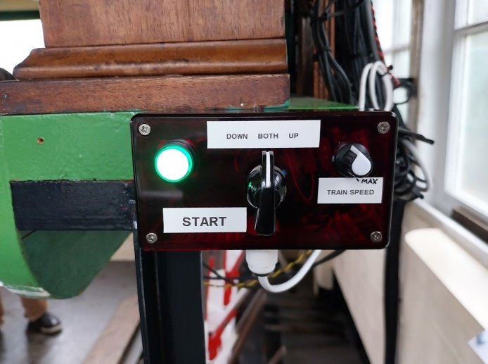
Control box (RH end of blockshelf)

